CS330: Programming Language Project (PLP)

Assignment 2: Installation, programming environment, and Hello, World!

**How to Install Java for Windows**

1. **Before you download anything**

Prior to installing Java, you must check to see if you have a version of Java already installed in your computer. To do that, you must **search “*Command Prompt*” or “*cmd*” in the Start Menu**, and start the Command Prompt application. Once the application is open it should look like the first image below.

Within the Command Prompt type “*java -version*” to see what version of Java your computer has if it has any. If it does the command prompt terminal will output a response similar to **Case 1**, where the version of Java is illustrated. In the case that your computer does not have Java (i.e. **Case B**) , the output will be this response:

*‘java’ is not recognized as an internal or external command, operable program*

*or batch file.*

If Case B is the case we can go on to downloading Java in **Part B**.

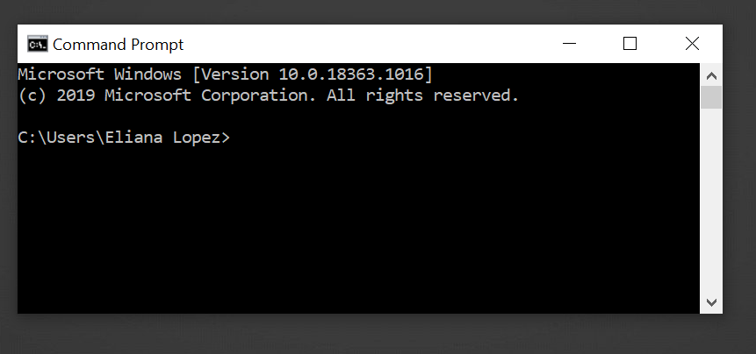

This is what the Command Prompt Application looks like!

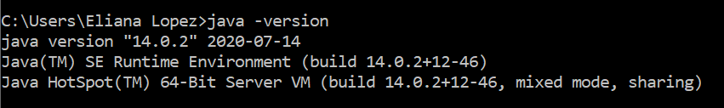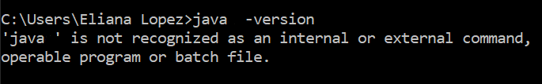**Case 1**: If Java is in your computer

**Case 2**: If Java is not in your computer

1. **Installing Java**

To download Java, you must go [Oracle’s Java SE Development Kit Downloads page](https://www.oracle.com/java/technologies/javase-jdk14-downloads.html) and scroll down to the **Java SE Development Kit** heading. The version does in this case is 14.0.2, but you can do this for any other version such as 13.0.2 or 11.0.8.

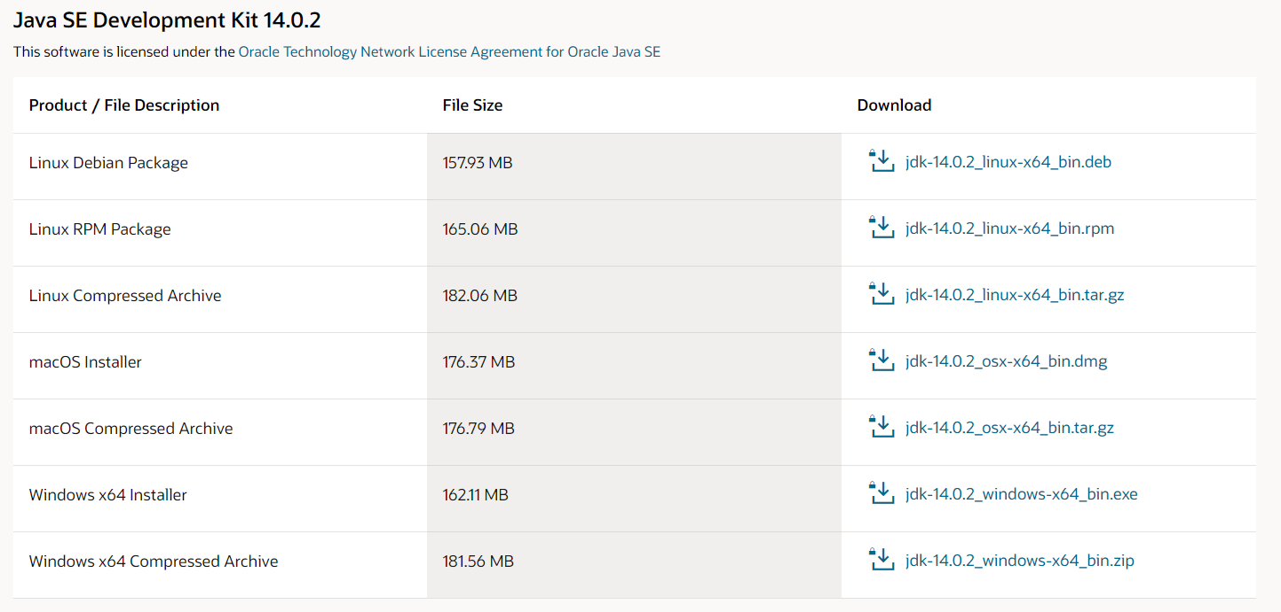

Download *jdk-14.0.02_windows-x64_bin.exe*

You then click on the Windows x64 Installer, and I personally recommend the downloading the executable file, **.exe**, for ease rather than the zip file, which I have boxed above.

Windows might response with a pop-up about installing apps for protection purposes but we will click **Install anyway** for ease once again.

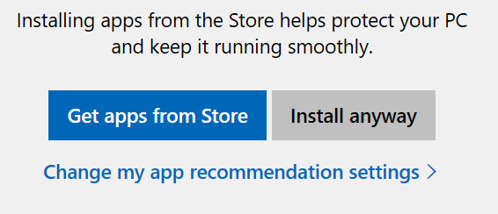

Click *Install anyway*

The Java Installer will then appear right away, and you will **click next and leave everything to its default settings.** The two images below show what the process looks like.

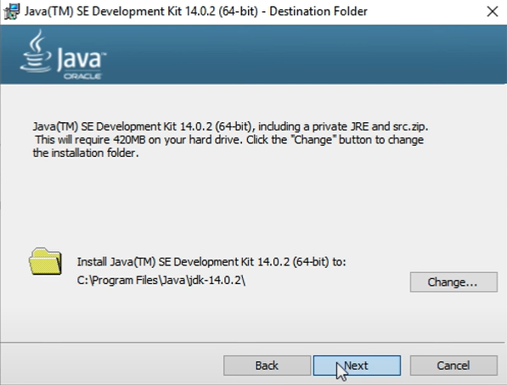

Keep click next, leaving everything to default

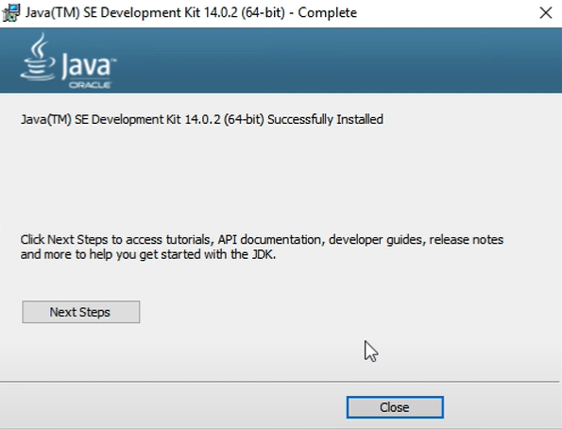

This will appear once Java has successfully installed

1. **Checking for Java**

After Java has downloaded successfully, to check to see if Java is in your computer you have to go to your **files** and to your C drive **(C:)**,or any drive you downloaded Java in. You then check your program files from that respective drive. In the Java folder you should see one other folder inside it named **jdk**, and inside that folder, **multiple other folders** with files that help the program operate. That means you have downloaded Java successfully!

Another way to check for Java is by following the instructions in **Step A** once again by utilizing the Command Prompt application once again, and typing “*java –version.*” You should see an output of the version of Java you downloaded from the Oracle website.

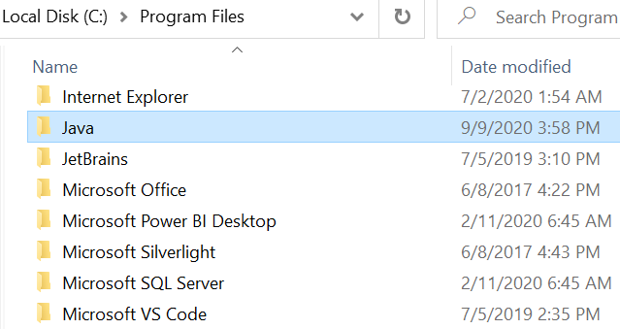

*C:\Program files*



*java –version*

1. **Setting Environmental Variables in Java**

The last thing you have to do is **set your environmental variables** for Java just to making things easier to run. What setting the environmental variables would do is provide a path for compiling a Java Program.

To do this you must **go to the Start menu and search “*Environmental Variables*,”** you would then see a shortcut to your control panel that says “***Edit the system environment variables***” which you would click. A window called Systems Properties will then pop up and in the section Startup and Recovery you have to **click on the Environmental Variables button**.

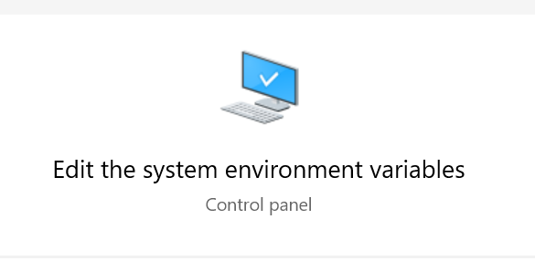

Click this from the Start Menu

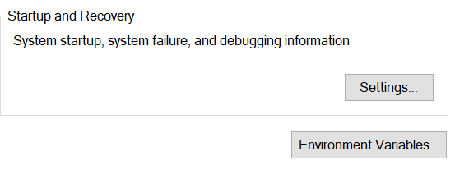

Click Environmental Variables

You then have to clicked *Environmental Variables*, you would then search for **Path** in the Systems Variable section of the window (see **Image A**) **click Edit...**, **click new,** and copy paste the file directory that the Java folder is located (*See program files image in* ***Step C***),go to the JDK folder and lastly go to the bin folder and click on the file navigation search bar and you should have something like this:

*C:\Program Files\Java\jdk-14.0.2\bin*

You then paste this to the empty row and you should have something like **Image B**. Then click okay and you should be back in the *Environmental Variables* window once again. Once you are in the window again you will click new this time, just like in **Image C**.

**Image A**

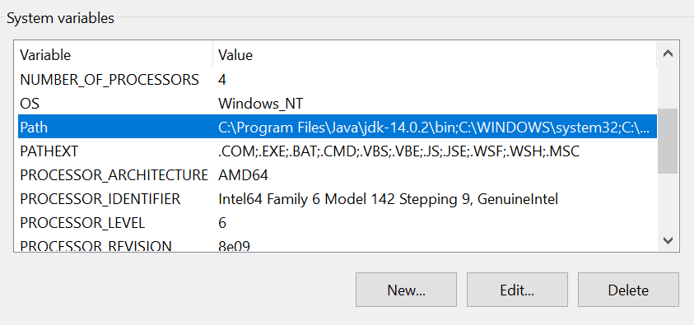

Go to Path and click on the *Edit...* Button

**Image B**

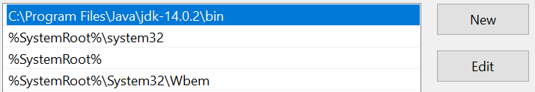

Click the New Button and paste “ *C:\Program Files\Java\jdk-14.0.2\bin*” from the file window

After you click new you are directed to a new window that pops called *Edit System Variable* out and you **fill the two text columns, Variable name and Variable Value** as seen in **Image D**. Variable name would be called “JAVA_HOME” and variable value would be a copy paste of the Java file directory all the way up to the JDK folder, *C:\Program Files\Java\jdk-14.0.2.*

When these columns are filled out you click on *OK* and **you are ready to start programming with Java!**

**Image C**



Click *New...*

**Image D**

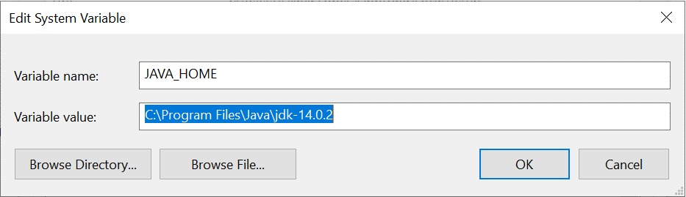

Then name the variable JAVA_HOME and copy paste the variable value from the file window

Variable Value: *“C:\Program Files\Java\jdk-14.0.2”*

Then click *OK* and you are all done!